**1.Installation/ Site Instructions**

Mantis offers educational institutions the ability to detect any forms of plagiarism in code assignments. Using the Mantis URL students and Instructors are given the opportunity to create a user profile. The Instructor will have a unique sign up page where they should provide a key given by Mantis to verify the institution. Both the student and the instructor will have access to submit or analyze coding assignments. Instructors will use the digital key given upon registration to create different classes for students to submit their work. The instructor will also be given the ability to set a particular date to stop accepting assignment submissions, once this is done it will allow mantis to compare the submitted assignments and detect any similarities between them. Also, the instructor is given the ability to edit and extend the date for assignments if needed. Once all assignments have been submitted or the deadline has arrived the instructor will be given the opportunity to submit the folder of assignments to Mantis. Once this is done Mantis will run its plagiarism detection algorithm and analyze each assignment to one another, this will take a few minutes and the instructor will be notified once it is complete. Once the similarity report is generated the Instructor will be able to analyze the similarity between different assignments, if an assignment is worth analyzing further the Instructor is able to compare both assignments side by side. The similarity report identifies the username of each student with the percentage of similarity between different students, those with a high similarity percentage will be highlighted and can be further analyzed by the professor. The website provides a platform for both student and instructor to communicate and attain feedback based on the results of the similarity report.

**2.System Architecture**

The system is based on three components, the main system that is run through Java Runtime Environment, the web-based portion of our product using HTML, CSS and PHP and the database portion of our product created with Mongodb .

**2.1 Mantis System (Java)**

The Mantis system begins by receiving the zipped files of each individual student assignment, it then goes through each file in the folder and chooses the source files submitted, for example all .cpp files or .java files. Once the source files are extracted it then places them in a folder called processedfiles that has the individual student names along with a text document with all the source files of that assignment combined. Once this is complete the system then begins tokenizing each file in the processedfiles folder, it creates a different directory called tokenizedfiles. This folder contains a text file of each individual student along with the tokenized version of their code. Once the tokenization is complete it then compresses the entire folder into one .zip file and is sent for the next stage. The next stage of the mantis system is the comparison and similarity check, it takes the .zip file that has all the tokenized files and compares the files ***n*(n-1)*** times. For example, if a folder contained 32 files in total there will be 992 files with each student being compared to the other in that class submission. The comparison is then made by finding any similarities between students tokenized files, once the comparison is complete it then outputs a text file containing the results of the comparison. The text file indicates the two student ids that are being compared along with the similarity percentage and the lines found to be similar. Once the ***n*(n-1)*** comparisons are made into their individual text files it is then compressed into a .zip file and sent to the zipout directory to use for the report.

Each of these steps are combined with a Mantis main function that runs in Java Runtime Environment (JRE) 8. To run locally, it supports a jar file and requires unzipped folder in resourcelibrary directory and receive a report as a zip file inside zipout folder. The instructor is the only one given permission to run Mantis and can check the report page with the comparison results and percentages.

**2.2 Website (HTML/CSS/PHP)**

The Website component of our product communicates with the Mantis system to import files by the students while also generating reports for the instructor to analyze. The students will have the ability to upload their code assignments and each file will be uploaded to a directory in the Manis system. Once the submission deadline has past this component will no longer allow any submissions from the student. Once all files have been imported the Instructor will have the ability to run the Mantis system to begin the comparisons. Once complete the instructor will then be directed to the similarity report. To generate the similarity report the files from the zipout folder were used, each file contained the students names, the similarity percentage and the lines that were similar. Each of the files are parsed and the above lines are extracted to create the similarity report. On the similarity report any pair of students who had a similarity percentage of 50% or higher were highlighted as major concern, if the Instructor wishes to assess this comparison further they will be able to click the compare link and have the two assignment files side by side.

**2.2 Database (MongoDB)**

Our system subscribes to Microsoft Azures CosmosDB which utilizes the MongoDB API. The MongoDB is connected via MongoDB driver Mongoose. Since MongoDB is a document-based database mongoose provides logic that defines our document schema, this gives us control over how information is sent to the database. Information sent from our React front-end is send to our Node.js back-end via express. Express is a web framework/module that sits on Node.js server-side environment. Express gives us the ability to create a REST API, this allows our front-end to send get/post/delete requests and access resources stored in our database.

**3.Technical Specification**

**3.1 Overview/Objective**

This project is made to check for plagiarism among students in a class. The students will have a log in where they must upload their assignments to a database. Then the professor can send those assignments to a secure server that will compare each assignment with each other assignment, and give a report listing all possible pairs of assignments, and also scoring how similar each pair is.

This project hopes to catch plagiarising students, and protect the academic integrity and honour of the school.

**3.2 Business Case**

The problem that is being solved is some students getting away with cheating. The professor and all students are impacted because they all must use the project to manage their assignments. The business benefits is that the school will have an effective, cheap way to quickly detect plagiarism without risking student privacy.

**3.3 Risk/ Out of Scope**

One risk is the possibility of a false positive, labeling students who did not actually plagiarize as being too similar by chance. The professor should manually check any similar assignments and make their own judgement to minimize this risk.

One thing that is out of scope is to include a feature so that the professor and TAs can mark the assignments, and record the mark, within the same database that MANTIS is using. The school will have to maintain and use a separate marking software.

**4.User Manual**

**4.1SIGN IN AND REGISTRATION:**

You will need a user account.

There are two types of user accounts:

* Student
* Instructor

In order to make one you will need to click the “**SIGN IN**” button located in the top right corner of the webpage.

This will route you to the sign in page. As shown below. If you already have an exiting account, please provide your email address and password (the email and password used during registration). When you are done completing the form please click ‘**SIGN IN**’.

If you are not an existing user, you must click ‘**Click Here’**.

You will be routed to a create user profile page. This is where you decide if you are applying as student or an instructor.

The type of registration form will appear based on the selected user type (student or instructor).

**4.2 STUDENT ACCOUNT:**

John

Doe

JohnDoe@universityName.com

JohnDoe@universityName.com

Abcd1234

Abcd1234

Abcd1234

You are required to input a first name, last name, email address, a confirmation to your email address and password (with confirmation) as shown above. When the form is completed you must click ‘CREATE ACCOUNT’ which right under ‘Confirm Password’.

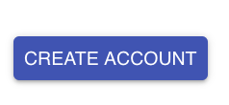

**4.2 INSTRUCTOR ACCOUNT:**

**Note an instructor must request a join key. A Mantis representative will review the request and supply the instructor with a join key.

The join key will be provided to the instructor in the format:

123e4567-e89b-12d3-a456-426655440000

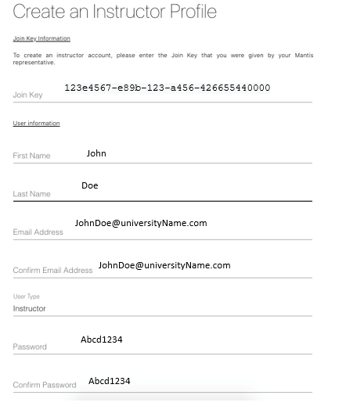

An instructor account is very similar to that of the student account. You are required to input a first name, last name, email address with confirmation and a password, also with confirmation. An example of this is shown above.

When the form is completed you must click ‘CREATE ACCOUNT’ which is again under the ‘CONFIRM PASSWORD’ text field.



DASHBOARD:

When signed in as a new user your dashboard should look something like this, as shown below.

The dashboard has your first and last name with account type (student or instructor). The dashboard gives you the ability to register to a course via the ‘**ADD COURSE’** button. If you are a student, you will have to register to course via course id.

**Note that the course id is provided by your instructor. The course id will be provided to the student in the format:

5cc379b774037c0b0481de42

As an instructor you are required to create a course via the ‘**ADD COURSE**’ button. This will prompt you to provide the form with a course name, a start date and an end date.

In order to add an assignment to your existing course you will have to click the ‘+’ symbol located in the top right corner of the course container. This is shown below. The ‘Run Mantis’ option when the end date is reached is used to run the mantis algorithm.

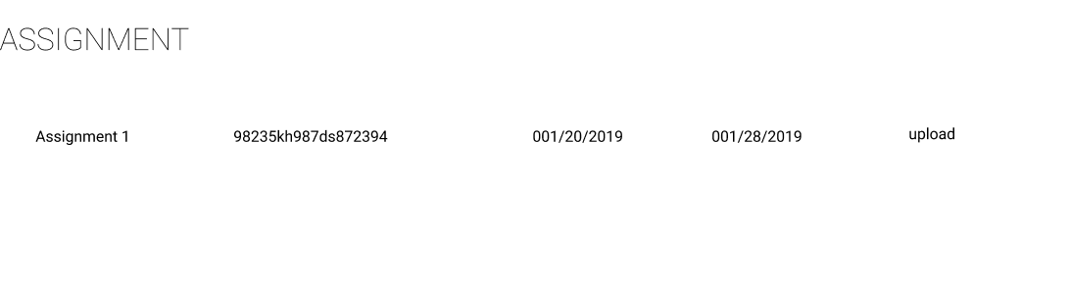The student is able to see the upload button but is not able to create a assignment with ‘plus’ symbol

